Project Report

Movie Recommendation System

Submitted in partial fulfillment of requirement for the degree

of MCA

Ajay Kumar Garg Engineering College-MCA, Ghaziabad

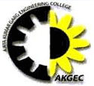

**Under Guidance of** **Submitted By**

Mrs. Arpana Saxena & Yash Dwivedi (21002770140064)

Mrs. Aman Gupta Pragya Bansal (2100270140037)

Shuchi Gupta (2100270140055)

**Dr. A.P.J. Abdul Kalam Technical University, Uttar Pradesh, Lucknow**

**(2022-23)**